TSMC 65nm Synthesis and Timing Report

All synthesis steps and tool commands
The RTL design was successfully mapped to the target TSMC 65nm standard cell library. The general synthesis flow included:
- RTL elaboration and structural mapping.
- Constraint application for both baseline and aggressive timing profiles.
- Extraction of Standard Delay Format (SDF) files for precise picosecond-level gate and net delays.
- Formal verification utilizing Logic Equivalence Checking (LEC) to verify the structural netlist against the golden RTL.
Tool Commands:
- Library & Setup: read_mmmc, read_physical -lef
- RTL Parsing & Elaboration: read_hdl -sv, elaborate, init_design
- Synthesis & Optimization Pipeline: syn_generic -physical -create_floorplan, syn_map -physical, syn_opt
- Equivalence Checking Setup: write_do_lec
- Reporting: report_timing, report_area, report_gates, report_power, report_qor
- Data Export: write_hdl, write_sdf, write_db

Design constraints and setup
The synthesis was driven by two primary constraint profiles to evaluate the performance limits of the design:
- Baseline Setup: Formulated to verify general design stability and positive timing margins. The synthesized database for this run is captured in riscv_core_synth_baseline.db.
- Aggressive Setup: Formulated to push the critical path to its absolute theoretical limit, minimizing clock periods to test standard cell capabilities. The database for this run is captured in riscv_core_synth_agg_clk.db.

Area, power, and timing results
- Baseline Timing: The baseline setup utilized a clock period of 10000.0 ps. Static timing analysis confirmed a critical path setup slack of 0.0 ps.
- Aggressive Timing: The aggressive setup minimized the clock period to 5730.0 ps. Static timing analysis confirmed a critical path setup slack of 0.0 ps.
- Baseline Area: The baseline configuration resulted in a total area of 30802.654. This includes a cell area of 18903.960 and a net area of 11898.694 across 5580 total instances. The logic distribution consists of 1024 sequential cells, 625 inverters, 274 buffers, and 3657 logic cells.
- Aggressive Area: The aggressive configuration resulted in a total area of 50591.121. This includes a cell area of 34884.000 and a net area of 15707.121 across 8954 total instances. The logic distribution consists of 1024 sequential cells, 1236 inverters, 477 buffers, and 6217 logic cells.
- Baseline Power: The baseline design consumes a total power of 2.02354e-03 W. This total is divided into 9.07672e-07 W of leakage power, 1.40317e-03 W of internal power, and 6.19465e-04 W of switching power.
- Aggressive Power: The aggressive design consumes a total power of 5.34965e-03 W. This total is divided into 2.29419e-06 W of leakage power, 3.38515e-03 W of internal power, and 1.96221e-03 W of switching power.

Issues encountered and how they were resolved
The primary issue encountered during the synthesis flow involved naming differences between the signals in the original RTL and the synthesized structural netlist. These naming discrepancies were resolved by properly mapping the signal names to ensure accurate equivalence checking and post-synthesis simulation.

Simulation comparison with waveform snapshots (RTL vs post-synthesis)
[Empty Place for Post-Synthesis Data]

Formal Verification (LEC) Results & Design Data Summary
To ensure the integrity of the design throughout the physical synthesis flow, Logic Equivalence Checking (LEC) was performed in two stages using Cadence Conformal: first comparing the golden RTL to the initial mapped netlist, and second comparing the mapped netlist to the final optimized netlist.

Stage 1: RTL vs. Mapped Netlist
The first verification stage checked the original RTL against the structurally mapped netlist. The verification completed successfully, proving 100% logical equivalence.
Mapped Points Summary:
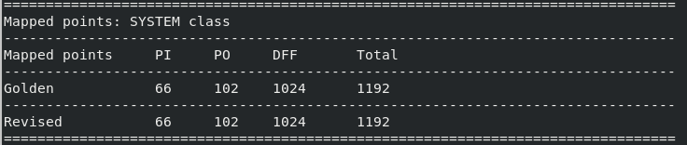
The tool successfully mapped all 1,192 system class points between the Golden (RTL) and Revised (Mapped Netlist) designs. This perfect mapping confirms complete structural alignment without any missed registers or I/O ports, and includes:
- 66 Primary Inputs (PI)
- 102 Primary Outputs (PO)
- 1024 D-Flip-Flops (DFF)
Verification Highlights:
- Perfect Equivalence: The tool verified 1,126 compare points (state-holding elements and outputs), resulting in 1,126 equivalent (EQ) points and 0 non-equivalent (NON-EQ) points.
- Dead Code Optimization: The golden RTL contained approximately 3% unreachable gates (typical of parameter-driven conditional logic). The synthesis tool successfully optimized these away, resulting in 0% unreachable gates in the revised mapped netlist.
Verification Highlights:
- Perfect Equivalence: The tool verified 1,126 compare points (state-holding elements and outputs), resulting in 1,126 equivalent (EQ) points and 0 non-equivalent (NON-EQ) points.
- Dead Code Optimization: The golden RTL contained approximately 3% unreachable gates (typical of parameter-driven conditional logic). The synthesis tool successfully optimized these away, resulting in 0% unreachable gates in the revised mapped netlist.
Design Data Summary Breakdown:
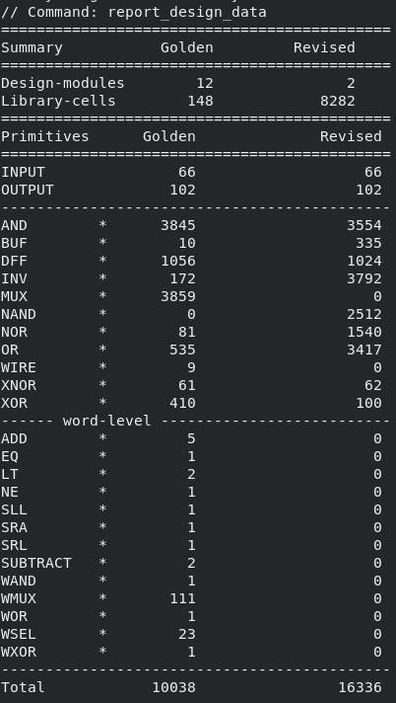
The design data report provides a clear view of how the synthesis tool translates abstract behavioral code into a physical implementation:
- Hierarchy Flattening: The design modules were reduced from 12 in the RTL to 2 in the mapped netlist. This indicates that the synthesis tool flattened the design hierarchy, absorbing smaller sub-modules into larger top-level blocks to optimize for timing and area.
- Standard Cell Mapping: The number of library cells increased massively from 148 to 8,282. This represents the translation of abstract logic into physical TSMC 65nm standard cells.
- I/O Integrity: The primary input count (66) and output count (102) match perfectly between both designs, confirming that the top-level interface boundaries remained intact.
- Logic Translation: High-level, word-level RTL operators such as ADD (5), SUBTRACT (2), and WMUX (111) present in the golden design were completely dissolved. To achieve the exact same mathematical function physically, the tool synthesized these behaviors into 16,336 gate-level primitives, heavily utilizing standard NAND, NOR, INV, and OR gates.

Stage 2: Mapped vs. Optimized Netlist
The second verification stage checked the initial mapped netlist against the final optimized netlist. The verification completed successfully with a PASS result, proving 100% logical equivalence between the two physical stages.
Mapped Points Summary:
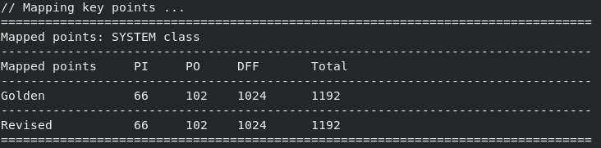
The mapped points remained perfectly consistent between the initial mapped netlist and the final optimized netlist. All 1,192 points (66 PI, 102 PO, 1024 DFF) were successfully mapped, proving that the physical optimization engine (syn_opt) did not erroneously remove, merge, or drop any sequential elements or boundary ports during timing recovery and buffering operations.
Verification Highlights:
- Perfect Equivalence: The tool verified 1,126 compare points, resulting in 1,126 equivalent (EQ) points and 0 non-equivalent (NON-EQ) points.
- Clean Logic States: Both the golden (mapped) and revised (optimized) designs contained exactly 0% unreachable gates, confirming the logic was completely and cleanly optimized during the initial mapping stage.
- Signal Handling: Floating signals were appropriately tied to Z, and revised X signals were successfully set to E to prevent false passes on unknown logic states.
Design Data Summary Breakdown:
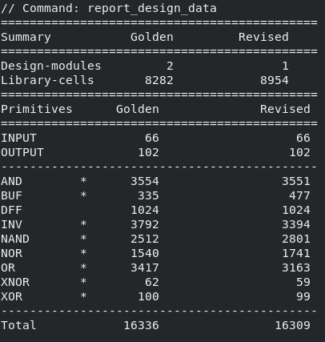
The design data report provides insights into the physical optimization engine's (syn_opt) impact on the mapped netlist:
- Further Flattening: The design modules were reduced from 2 to 1, indicating a completely flattened top-level design for final physical optimization.
- Library Cell Increase: The number of library cells increased from 8,282 to 8,954. This 8% increase is typical during the optimization stage, as the tool inserts additional buffers (which increased from 335 to 477) and resizes gates to fix design rule constraints (DRCs), fanout violations, and setup/hold timing paths.
- Sequential and I/O Integrity: The primary inputs (66), outputs (102), and D-Flip-Flops (1024) remain perfectly constant, confirming no sequential elements were illegally absorbed or duplicated.
- Logic Restructuring: The distribution of logic primitives shifted (e.g., NAND gates increased from 2,512 to 2,801, while Inverters decreased from 3,792 to 3,394). Despite the increase in physical library cells, the total primitive count slightly decreased from 16,336 to 16,309, demonstrating that the tool efficiently restructured the boolean logic into more complex standard cells to achieve the tight setup timing targets.

